Sprint 1 retrospective

By Gerardo Flores, Ahram Kim – CCP Tour App

# Sprint demo

On this first sprint for our CCP Tour App, we collected information and pictures from our sponsor. We also learned how to implement pictures into our app, using HTML, CSS, and JS.

# Definition of done

* Code builds without warnings
* Code unit tested
* All acceptance criteria have been met
  + Ionic, HTML, CSS, JavaScript
* Collected data from sponsor, Ashley
* We have tested to connect to Ionic framework and not found any defects
* All the automated tests for the user story run without failing
* Pair programming is done
* Build pushed to demo server

# Burndown chart and velocity

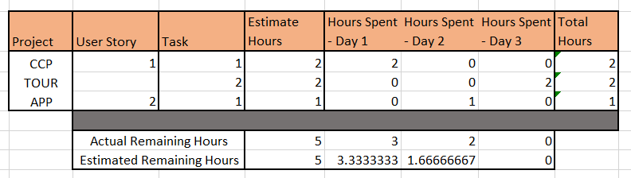

# Defect removal activity

Publish metrics for each defect removal activity per Definition of Done

NOTE: On brand new features you may have not identified any defects yet so you may not have anything to report in this section.

# Project Name: CCP TOUR APP

Team member (print/sign):_____Ahram Kim_________________________________________________

Team member (print/sign):_____Gerardo Flores_____________________________________________

Sponsor name (printed): Ashley Beasley

**Sponsor signature:** _________________________________________________________________________

Date: 09/12/2018

Sponsor checklist:

* I have seen the user stories completed demoed and they appear to work and meet the DOD
* Team has provided me with a burn down chart and velocity

Sponsor Comments: